Reverend and Dear Pastors,

Bishop Vann and his advisory team met this morning to discuss a number of issues related to the COVID-19 (“Coronavirus”). On this team are Bishops Vann, Freyer and Nguyen, Vicar General Monsignor Stephen Doktorczyk, Human Resources Director Thomas J. Burnham, Chief Finance Officer Elizabeth D. Jensen, Director of Communications Tracey B. Kincaid, Director of Youth and Young Adult Ministries Armando Cervantes, Director of Respect Life, Peace and Justice Greg Walgenbach, and Consultants Michael Hunn and Kevin Buck. Realizing that directives are subject to change on very short or no notice, I ask you to take note of the following important information:

1. Following the guidance of the Archdiocese of Los Angeles (our Metropolitan See), effective no later than Tuesday evening, March 17, 2020, public Masses are hereby suspended. Bishop Vann wants churches to remain open so that the faithful may pray privately (for example, the Rosary or other devotions), with procedures in place to limit attendance so that people may be spread out in the church.

2. Pastors may wish to consider exposing the Blessed Sacrament, limiting the number of people present in the church at any given time.

3. Please encourage your people to view Mass via Livestream. As of this writing, we are aware that St. Edward the Confessor livestreams their 8:15 a.m. morning Mass from Monday through Saturday and 9 a.m. on Sunday at <http://stedward.com/stedcast/>. Beginning Wednesday, March 18, 2020, Christ Cathedral will livestream daily Mass in English (6:30 a.m.) and Vietnamese (5:30 p.m.), in addition to the Sunday livestream Masses already communicated to you at [facebook.com/christcathedralca](http://facebook.com/christcathedralca).

4. In line with the norms of the Universal Church, Bishop Vann earnestly recommends that each priest in our Diocese celebrate Holy Mass daily, “since, even if the faithful cannot be present, it is the act of Christ and the Church in which priests fulfill their principal function” (canon 904). Mass intentions accepted at the parish are to be offered by the priests so as to keep continuity.

5. Attached to this memo is a letter regarding the generous offering of confessions.

6. Please avoid giving blessings to large groups of people. Individual blessings are encouraged.

7. Funerals, weddings and quinceañeras should be celebrated, ensuring that social distance norms be enforced.

8. Priests over 65 years of age and/or with an underlying medical condition are encouraged to follow the advice of their doctors.

9. As regards Holy Week liturgies, First Holy Communion, and Confirmations, determinations have not yet been made and will be communicated in due course

10. No one in the Diocese of Orange (including in the Pastoral Center) took advantage of awebinar held this past Friday in which topics such as “how to livestream Mass,”“communications plan and ideas for your parish,” and “tips for parish staff working remotely”were discussed. I invite you and others in your parish to view this material at your earliestconvenience (<https://prengersolutions.com/webinar-2020-coronavirus?utm_source=Prenger+Solutions+Group&utm_campaign=38aae5f18fEMAIL_CAMPAIGN_2019_11_02_02_44_COPY_01&utm_medium=email&utm_term=0_32b8d285a7-38aae5f18f-197989098>).

11. We are aware that there are human resources and financial considerations that need to beaddressed. We anticipate a significant reduction in donations, and encourage priests to becreative in putting forth the need for continued generosity. More information will be

forthcoming.

12. Consider phoning elderly parishioners to ensure that they are okay. Some are alone andunable to get out of the house. A call from their parish would go far to encourage them.

13. It is understandable that elderly volunteers would decide to step back from ministering tothe sick at this time. This might be an opportunity to recruit younger members, who could betrained using electronic means if necessary.

14. Please share your good ideas with your brother priests.

15. There are plans in the works for the bishops to have twice-weekly calls with the pastors(administrators/directors). Your input is valuable, and we at the Pastoral Center are most awarethat we do not have all the answers.Let us continue to prayerfully support each other.

In Christ,

Msgr. Stephen Doktorczyk

Vicar General and Moderator of the Curia

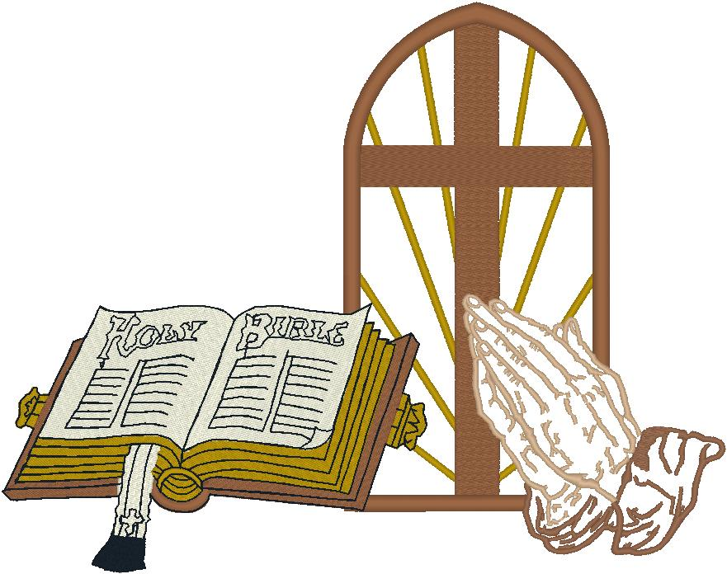THÔNG BÁO KHẨN CẤP TỪ GIÁO PHẬN ORANGE

GUIDELINES CORONAVIRUS FROM ORANGE DIOCESE